RSM 222 – CHAPTER 12 HANDOUT
RELEVANT COST FOR DECISION MAKING

SITUATION 1: KEEP OR DROP A PRODUCT / SEGMENT
Belair Bistro is a French bistro located in Yorkville. The Bistro is composed of a sit down bistro with service and a daily menu for lunch and dinner while the front of the restaurant is a take-out bakery and café.
For the past 2 years, Belair has been operating an online platform through their website that allows customers to place orders on-line and have the food delivered to them within 45 minutes. The Online delivery platform is managed from a small office located at the back of the restaurant. Belair’s manager, Mr. Gabriel, is considering dropping this segment as he believes it is not profitable. The maintenance of the IT platform has been expensive and he also believes that the online orders take up a significant portion of his time while making up a small portion of the revenues. Gabriel believes his time could be put to better use with other projects and initiatives for the Bistro as well as managing the current operation. Gabriel indicates that staff turnover has been higher this past year and he feels partly responsible as he has not been able to be as involved with supervising and coaching the staff.
The feedback from the platform has been generally good and he noted that many new customers of the café indicated that they discovered the café after they saw the website and ordered delivery from the online platform.
Gabriel, provides you with the following financial information of the Bistro and asks you to help him decide whether they should keep or drop the Online Delivery Segment.
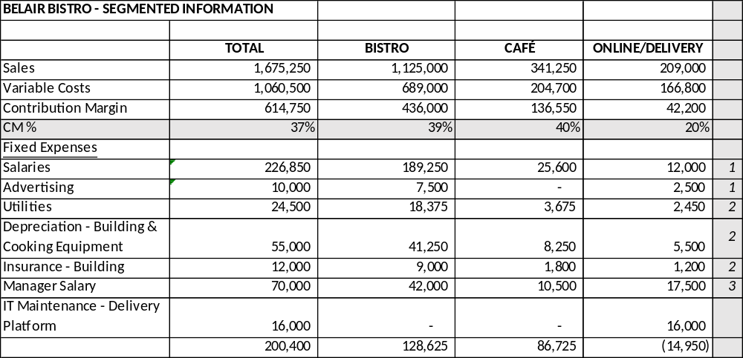
Note 1: The Salaries and Advertising expenses are direct and traceable costs of each segment.
Note 2: These common fixed costs were allocated based on the square footage of the building occupied by each segment.
Note 3: Gabriel indicated that he estimates he spends 60% of his time working at the Bistro, 15% for the café, and 25% for the online delivery platform. His salary was allocated based on this basis.
REQUIRED:
Identify the relevant costs to the drop analysis and prepare a computation of the loss/gain in income that would result from dropping the segment.

What qualitative factors would you consider in this decision?

SITUATION 2 – MAKE OR BUY A PRODUCT

Pierre, the pastry chef of Belair Bistro indicates that he has been approached by Le Louvre Bakery. Le Louvre indicated that they could bake all of the 150 croissants the café needs on a daily basis for a cost of $1.15 per croissant. Pierre is considering this offer since croissants are very time consuming to make. They take on average 3 hours of his time every morning. He feels that he could use this time to make some pies and cakes, which could be sold at the café.

Pierre has summarized the information from the offer below:

Offer from Le Louvre:
- To bake 150 croissants each day at $1.15 per unit.
- A daily delivery charge of $40 would be applied.
- Any change to the quantity ordered needs to be communicated at least 48 hours in advance.
- The current terms are valid for 1 year, at which point the contract can be renegotiated.

The current direct materials of making the croissants is $0.95. The variable overheads associated with the croissants are estimated at 10 cents per croissant. Pierre is not paid on an hourly basis, so cutting the croissant line would not affect the salary expense.

Pierre believes that he could make 25 pies with the time he would save. On average, the pies would provide a contribution margin of $3.5 per pies. Pierre is very excited about this opportunity as he feels that making pies allows him to be much more creative than making croissant. Pierre also indicated that the croissants use a special oven that could be sold as it would no longer be needed. The oven was purchased 6 years ago for $8,500. However, as there is not a large re-sale market for used bakery stove, they could only get $2,500 if they sold it today.

REQUIRED:
Identify the relevant costs to the make or buy decision of the croissants.

What qualitative factors would you consider in this decision?

SITUATION 3 – UTILIZATION OF A CONSTRAINED RESOURCE

Belair Bistro identified that the café’s main bottleneck is Pierre’s time. If Pierre, the pastry chef, could work additional hours, the café would be able to have more baked goods to sell.

The manager is currently reviewing the quantity of each item that should be produced on a daily basis. During the afternoon, Pierre usually spends his time baking macarons and quiches. Everyday, the café sells out of the boxes of macarons and quiches. The demand for both product therefore far exceed the daily production of the café.

The following information about the products is provided to you by the manager:

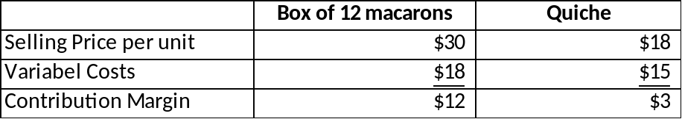

Chef Pierre explained that the macarons are an art and require a lot of time and precision to make. He therefore spends 18 minutes of his time on each box of 12 macarons while a quiche only requires 8 minutes of his time.

REQUIRED:
Which item should be prioritized by Pierre in order to ensure that Belair has the highest profit?

